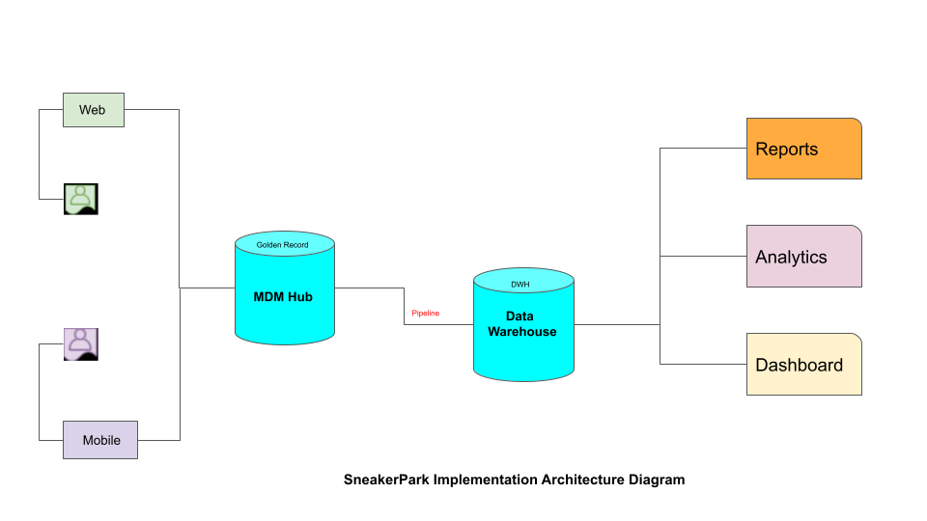

**Background**

SneakerPark’s business model is that of an online reseller. With a valid registered account, Sellers can have their Sneakers listed for sale upon passing inspection. Buyers are required to have a registered account to bid or purchase Sneakers through SneakerPark’s website. If a Sneaker is listed, sold and the transaction successfully completed, the Sneaker will be shipped to the Buyer, then, Seller’s account is credited with the set amount and SneakerPark keeps the difference for service and shipping fee. If a Sneaker does not pass inspection, it is returned to the Seller, and, in which case the Seller pays for shipment. If the Sneaker is not listed in 45 days, it will be returned to the seller along with an invoice for shipping cost.

**Challenges For SneakerPark**

SneakerPark is faced with growing data infrastructure needs, as well as, customer dissatisfaction resulting from discrepancies between systems leading to mischarges and lost revenue.

**Justification for this approach**

**The proposed architecture is Centralized Metadata Management (MDM-Hub).**

1. Information about the current system is very sketchy with little to no detail. Centralized MDM-Hub provides for other requirements that may exist or emerge in the process in terms of accommodating and incorporating the existing systems.
2. Golden record is created in the MDM-Hub, which offers a higher-level of consistency and accuracy in real-time updates. If needed, synching with other source systems will be easily achievable. Although with a much higher cost of implementation, it addresses most of the issues identified with the SneakerPark’s current system and operations.
3. Analytics with applicable visualization and dashboard can be easily created with this architecture. There is always a story to tell with data. However, the architecture must be such that it allows for proper analysis of performance.
4. Data Warehouse is included for growth and expansion purposes.

Overall, the implementation strategy is to start small at the core-domain with the necessary attributes and incrementally expand towards complete migration.